Name Of The Student | Garima Modiyani
Internship Project Topic | TCS iON RIO-210: Build a Classification Model for Drug Trials Dataset
Name of the Organization | TCS iON
Name of the Industry Mentor | jignasha royala
Name of the Institute | Amity University

Date | Day | Hours Spent
20-11-2025 | Day-40 | 4 hours 40 minutes
Activities done during the day:

Project Hands-on – Preprocessing the data

Link of the google drive google Colab file :-
https://colab.research.google.com/drive/1VQRq0l6oc9Uj4cOOqiuhkfS1JmpKr3fU?usp=sharing
Data preprocessing is a crucial step in the data analysis pipeline where raw data is transformed into a format that is suitable for analysis and modeling. Here are some common techniques used in data preprocessing:

Handling missing values
Data cleaning
Feature scaling
Feature encoding
Feature selection
Data transformation
Normalization
Data splitting

data = data.drop('Age Range', axis=1)

# Filter out ages outside the range of 100
filtered_data = data[data['AGE'] > 90]
print(len(filtered_data))

# Print the output
filtered_data.head(20)

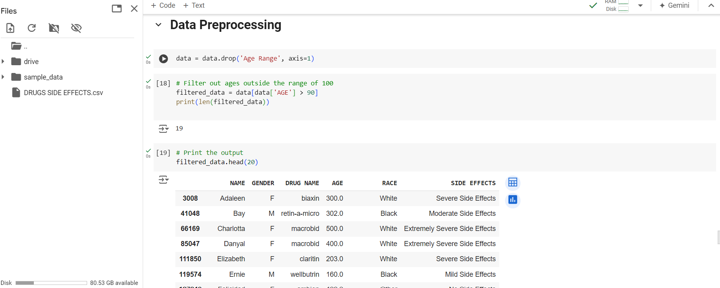

Define a function to process the age values
def process_age(age):
if age > 100:
return int(age / 10)
return age

# Apply the process_age function to the 'AGE' column in data
data['AGE'] = data['AGE'].apply(process_age)

# Print the corrected DataFrame
data.head()

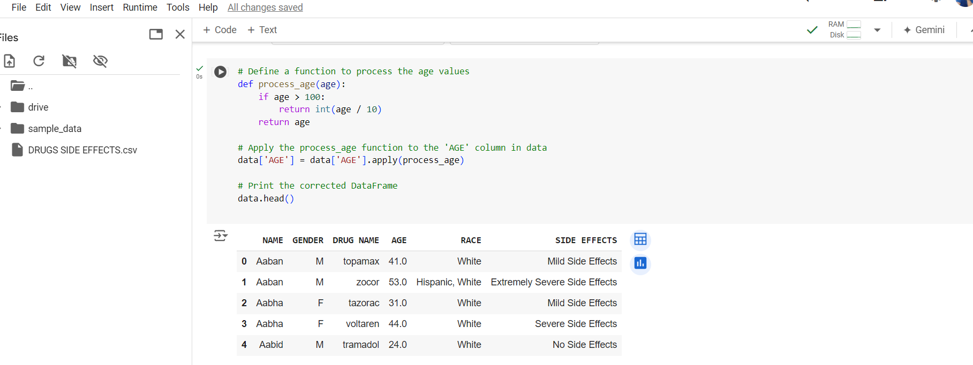

# Filter out ages outside the range of 100
filtered_data = data[data['AGE'] > 90]
print(len(filtered_data))

# Calculate the mean age
mean_age = data['AGE'].mean()

# Replace null values with the mean age
data['AGE'].fillna(mean_age, inplace=True)

data.isnull().sum()

